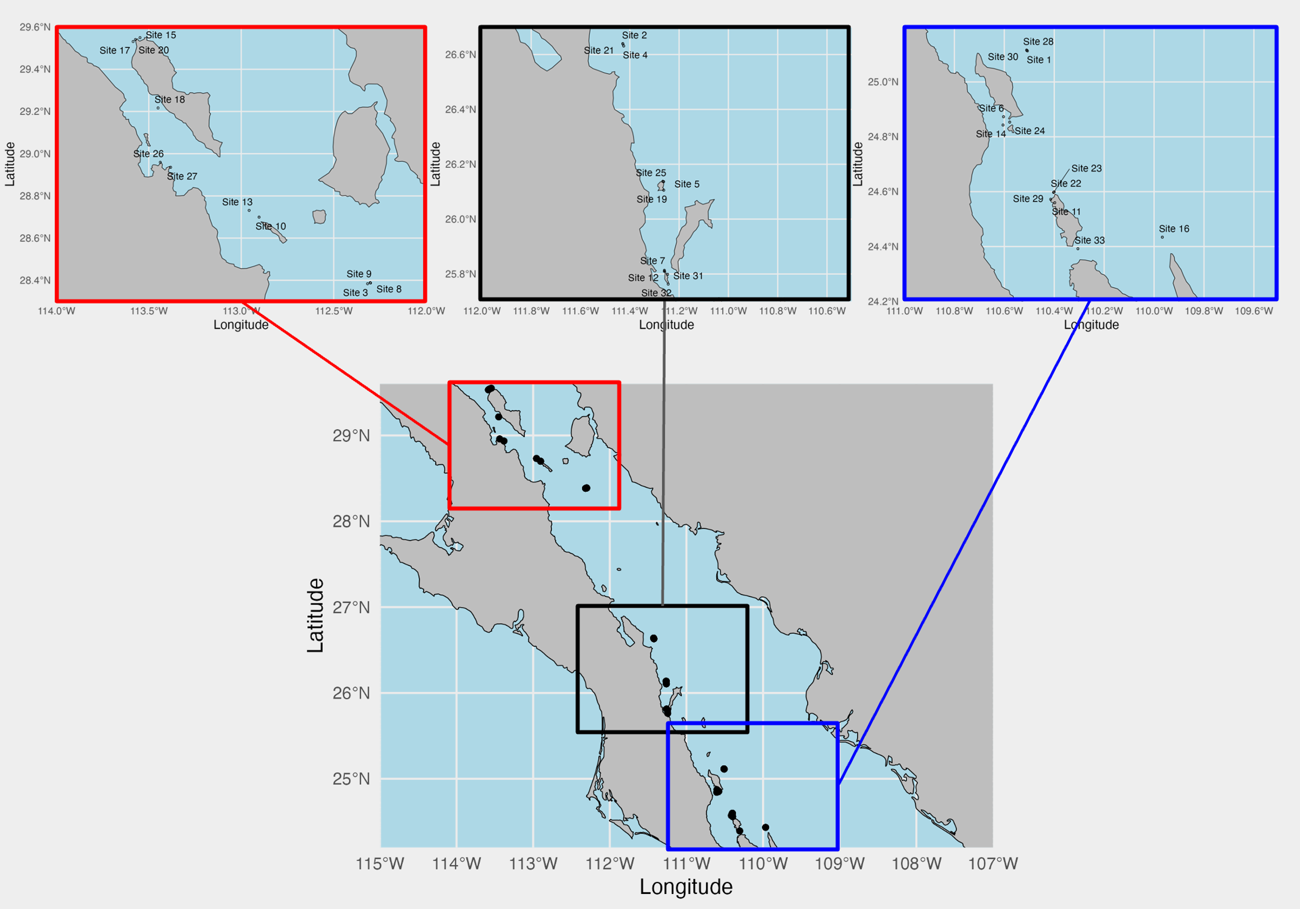

Figure 1: Map of sampling sites in the Gulf of California. Bottom map is all sites. Top three maps are subsets of three latitude groupings: northern sites (red), middle sites (black), and southern sites (blue).



Figure 2. Venn diagrams showing species overlap (top) and family overlap (bottom) between PEDS and RVS for a) original PEDS species and b) updated PEDS species.



Figure 3. Diagram of stages of adding fish sequences to our reference database (left blue boxes) and resultant total PEDS species (right white boxes).



Figure 4. Alpha diversity plots for PEDS using Simpson’s diversity index for six metadata variables: latitude group (a), most common habitat (b), maximum dive depth (c), diver (d), bottom time (e), and transport time (f).



Figure 5. Alpha diversity plots for RVS using Simpson’s diversity index for five metadata variables: latitude group (a), most common habitat (b), maximum dive depth (c), diver (d), and bottom time (e).



Figure 6. NMDS beta diversity plots for PEDS following Hellinger transformation of data for latitude group (a), most common habitat (b), maximum depth (c), diver (d), bottom time (e), and transport time (f).



Figure 7. NMDS beta diversity plots for RVS using Gower dissimilarity index for latitude group (a), most common habitat (b), maximum depth (c), diver (d), and bottom time (e).



Figure 8. Family composition in each site for PEDS (a) and RVS (b) for 9 families of overlap. The horizontal black lines in each bar in the PEDS plot represents a species within the family.



Figure 9. Heatmap depicting the number of species in each site for which PEDS and RVS had matching presence / absence data, where the similarity score represents the number of common species present in both or absent in both methods for a given site. a) is all sites, b) is North, c) is Middle, and d) is South sites.



Figure 10. Scatter plot with a linear regression between species overlap numbers and latitude. Slope is 0.025, R2 value is 0.21, and p-value of the regression is 0.007.